2014世界賽設備規定暨注意事項

競賽國小、國中、高中組和足球賽:
    - 機器人的控制器，馬達以及感測器都必須是LEGO® MINDSTORMS™系列（RCX，NXT，或者EV3）以及HiTechnic Color Sensor。機器人其餘的組裝零件也可以使用LEGO®品牌產品
WRO建議隊伍使用教育版的設備才能自LEGO EDUCATION當地推廣中心獲得更多的售後服務。
    - 參賽隊伍必須自行準備比賽會用到的設備、軟體和電腦。
    - 參賽隊伍於進場時必須自行斟酌所需的備用零件或器材，以防止可能發生的意外。若參賽隊伍所攜帶之設備發生故障，主辦單位不會負責維修或更換。
    - 比賽期間教練不得以任何方式對選手做任何諮詢或指導，唯組裝測試計時開始前，選手可透過工作人員向場外教練尋求協助。計時開始後選手除場地因素可向工作人員求助外，必須自行排除機器人或設備相關問題。
    - 比賽開始時，所有的機器人都必須是零件的狀態，不得有任何已組裝之零件，包括輪胎輪框、鏈條、電池…等。
    - 也不能攜帶說明書、機器人組裝圖片或文字（不論形式）。
    - 選手可以事先準備好程式。
    - 機器人不可使用螺絲、黏著劑或膠帶等物品來固定，違者將被取消比賽資格。
    - 程式軟體須為ROBOLAB™ ， LEGO® MINDSTORMS™ NXT或者LEGO® MINDSTORMS™ EV3 SOFTWARE。
*Labview只能在高中競賽組使用
 | Robolab | NXT Software | RobotC | EV3 Software | Labview*
RCX |  | ÷ | ÷ | ÷ | ÷
NXT |  |  | ÷ |  | 
EV3 | ÷ | ÷ | ÷ |  | 

    - 機器人使用零件、馬達和感應器都必須是LEGO®及HiTechnic(下表)，其餘公司產品將不被允許。參賽選手不得對零件（例如：EV3，RCX，NXT馬達，以及感應器等）做任何改裝，違者將被取消比賽資格。
注意：WRO 2014競賽組不能使用EV3 Gyro Sensor。若是參賽隊伍使用EV3，僅能使用三組馬達接頭。

5225 | 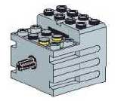 | RCX馬達
9758 | 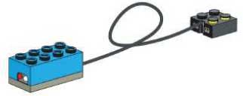 | RCX光源感應器
9889 | 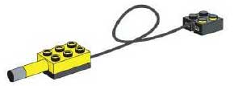 | RCX溫度感應器(9V)
9891 | 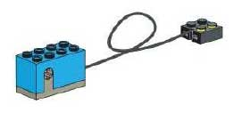 | RCX角度感應器(9V)
9911 | 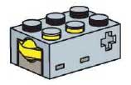 | 觸控感應器
9842 | 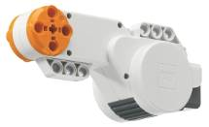 | NXT伺服馬達
9843 |  | NXT觸控感應器
9844 | 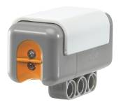 | NXT光源感應器
9845 | 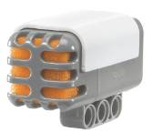 | NXT聲音感應器
9846 | 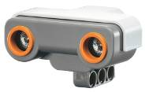 | NXT超音波感應器
9694 | 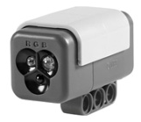 | NXT顏色感應器
45502 | 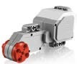 | EV3大型馬達
45503 | 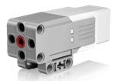 | EV3中型馬達
44504 | 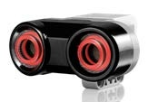 | EV3超音波感應器
44506 | 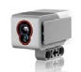 | EV3顏色感應器
44507 | 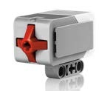 | EV3觸控感應器
44509 | 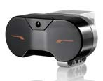 | EV3遠紅外線感應器
 | 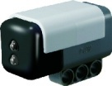 | HiTechnic NXT Color Sensor V2

    - 參賽隊伍不能攜帶比賽底圖、底板、道具、乾電池、NXT或EV3之鋰電池充電器進入會場，違者可能會被取消比賽資格。
    - 參賽隊伍最多可攜帶LEGO® MINDSTORMS™ Education NXT之9798或 9693或EV3-45501鋰電池3顆。比賽期間（包括組裝及測試）機器人只可以使用大會所提供的電池（每隊六顆三號）或自備的LEGO® MINDSTORMS™ Education NXT或EV3鋰電池來完成比賽和練習。

競賽大專組:
The only parts and materials allowed in the construction the Robot are listed below. No other parts and materials are permitted.
4.1. Any part from the LEGO®, MATRIX™ or TETRIX™ system with the following constraints:
4.1.1. No more than eight (8) DC drive Motors.
4.1.2. No more than eight (8) Servos.
4.1.3. No more than two (2) Rechargeable Battery Packs, which are identical to those supplied in the kit of parts.
4.1.4. You may modify metal parts to any size.
4.2. Any LEGO building element with the following constraints:
4.2.1. Exactly one (1) NXT Controller must be used.
4.2.2. The NXT controller must be powered either by the NXT rechargeable AC battery
4.2.3. (W979798), NXT DC Battery (W979639), or six (6) AA batteries.
4.2.4. LEGO Motors may be used with the following constraints (per NXT motor port):
• One (1) NXT Interactive Servo Motor (LEGO Part # W979842)
• One (1) XL Power Function Motor (LEGO Part # W778882)
• Two (2) E Power Function Motors (LEGO Part # W979670)
• Two (2) M Power Function Motors (LEGO Part # W978883)
• One (1) E Motor and one (1) M Motor
• You are allowed to use any number of NXT conversion cables to connect the Power Function Motors with the NXT (LEGO Part #s W770323, W778886, or W778871)
• You are NOT allowed to use any of the Power Function Battery Packs (LEGO Part #s W778881 or W778878)
4.2.5. LEGO pneumatic elements are allowed. Teams may not modify LEGO pneumatic elements to attempt to change the working pressure limits of the elements.
4.2.6. Any LEGO Approved NXT sensor (as indicated by the LEGO Mindstorms NXT Certified – Hardware label) is allowed.
4.2.7. Any NXT compatible sensor from HiTechnic, including the NXT Touch Sensor Multiplexer, NXT Sensor Multiplexer and the NXT prototype boards (both solderable and solderless) is allowed.
4.2.8. The HiTechnic 9‐volt Battery Box that is sold as part of the NXT Sensor Multiplexer set may be used in conjunction with each NXT Multiplexer (i.e. one Battery Box per Sensor Multiplexer). It may be used only in conjunction with and to power the NXT Sensor Multiplexer(s).
4.2.9. LEGO‐Approved NXT extension cables are allowed. Approved cables are currently only available from LEGO and HiTechnic.
4.2.10. Non‐NXT electrical elements not specified above are not allowed, with the exception of RCX sensors.
4.2.11. LEGO Duplo products are not allowed
4.3. Plastic‐coated wire rope with a bare wire diameter of 0.03125” (0.08cm) or smaller. Compatible compression sleeves, clamps and hardware may also be used only in conjunction with the plastic‐coated wire rope.
4.4. All mechanical fasteners (nuts, bolts, screws, etc.) of any length, any thread type, up to 3.5. 0.375” (0.9525cm) diameter. The intent of this rule is to allow teams to use fasteners from any supplier that are substantially the same as MATRIX/TETRIX fasteners. Compatible fasteners are characterized by using the same thread characteristics as MATRIX/TETRIX fasteners. For example, for MATRIX standard metric (M3, M4) screws are an acceptable substitute. For TETRIX 6‐32 thread, 1/2" length socket head cap screw is a 6‐32 thread, 3/4" length, button head cap screw purchased at a local hardware store. Any other non-metal parts are allowed with maximum thickness 0.2cm.
4.5. No additional components may be used, however functionless components used only for decoration and are easily removable as wanted are allowed.
4.6. Teams should prepare and bring all the equipment, software and portable computers they need during the tournament.
4.7. Contestants may write their program beforehand.
4.8. Control software must be LabVIEW for LEGO MINDSTORMS.

